IST/Clearing GUI Installation Procedure
Clearing 2.3.0

Document Version: 1.0

Contents

1 Introduction 3
2 Prepare For Install 4
2.1 Pre-Requisites 4
2.2 System Topology 4
2.3 Database Schemas 4
3 Installation Steps 4

Introduction

The IST Clearing GUI Installation Procedure Guide introduces the installation and pdeploy configuration of IST/Clearing GUI PADSS 2.3 application.

Prepare For Install

Pre-Requisites
The following must be made available before installation:
- Installed Database:
- Oracle application version 11g.
- Installed Web server:
- Tomcat
- Java JDK 6 or 7

System Topology
Before you begin, collect all system information required for product and GUI application installation:
- Decide on the system where each product server(s) will run, where the authentication and entitlement processes will run, and where the web server will run.
- Decide on the names for database schemas to be used and which products will be connected to them.
- Gather all system network names, database schema names and passwords.

Database Schemas

- Schema 1:- Clearing
- Schema 2:- Authenthication and Entitlement
- Schema 3:- Tokenization Service
- Schema 4:- Key Lifecycle Management

Installation Steps

- Login to the Unix Server 10.74.153.17 with correct user name and password
- Copy the GUI release file CLC_2.3.10.00.02_SOL-210_BASE.tar.gz from RCC path
- Extract the contents of above release file using below command

gzip –cd <ReleaseFileName> | tar –xvf -

Example: gzip –cd CLC_2.3.10.00.02_SOL-210_BASE.tar.gz | tar –xvf -
- The release gzipped tar files and build_env are extracted to $HOME/tgz
- Run "build_env" to install the files stored on $HOME/tgz as shown in below screen shot
- Select option 0 to continue installation

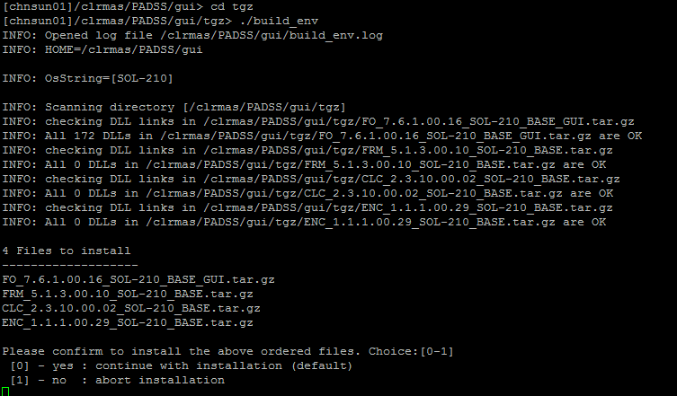

- Select option 1 in below binary test option

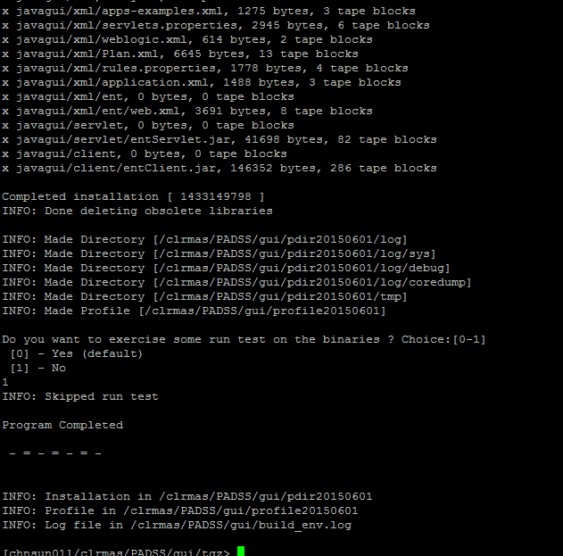
- On completion, the product directory and associated profile are created:
- A file is created with name, profile<install_date>.where,
profile is constant
install_date is the date in the format yyyymmdd.
Example: profile20150528

profile<install_date> contains the environment variables required for the application to run. For GUI deployment, these are also required and provide the facility to navigate more easily to various directories.
- A directory is created with name, pdir<install_date>. where,
pdir constant.
install_date is the date in the format yyyymmdd.

When multiple installations are done within the same day, the current pdir<install_date> is moved to pdir<install_date>_<n> where n is a number depending on the number of installations within the install date.
Example:
pdir20150528 current installed pdir<install _date> on 28th May 2015
pdir20150528_1 previously installed pdir<install _date> directory on 28th May 2015, moved to pdir<date>_n.
The pdir<install_date> directory contains the GUI files to be used in the deployment.
- The file build_env.log is updated with the installation information.

- Edit the ".profile" and replace the ". ./profile<yyyymmdd> with the current profile<install_date> filename created above.
- Re-login to apply the changes above.

- Execute pdeploy and so the following main menu is displayed as shown below

[chnsun01]/clrmas/PADSS/gui/tgz> pdeploy

IST Installation Utility v1.136
Product Directory: /clrmas/PADSS/gui/pdir20150528 (231)
+----------------------------------------+
| 0. Install GUI |
+----------------------------------------+

- Selecting Install GUI displays the following menu

IST Installation Utility v1.136
Product Directory: /clrmas/PADSS/gui/pdir20150528 (231)
Install GUI
+----------------------------------------+
| 0. Setup GUI Global Parameters |
| 1. Select GUI Subsystem |
| 2. Setup GUI Subsystem Parameters |
| 3. Reset to GUI Global Parameters |
| 4. Prepare GUI DB Scripts |
| 5. Create GUI DB Tables |
| 6. Undo Create GUI DB Tables |
| 7. Apply GUI DB Tables Upgrade Script |
| 8. Apply GUI DB Records Upgrade Script |
| 9. Insert GUI DB Records |
|10. Update GUI Ent_Object Records |
|11. Enable SSL |
|12. Generate WAR File |
+----------------------------------------+
GUI Menu Description:

Option | Description
0. Setup GUI Global Parameters | Displays the default set of variables.
1. Select GUI Subsystem | Displays a list of subsystems depending on the GUI applications present in $OPRODUCT_ROOT and allows selection for deployment.
2. Setup GUI Subsystem Parameters | Displays parameters that can be specified per subsystem.
3. Reset to GUI Global Parameters | Reset all subsystem parameters to the values set in the Global Parameters.
4. Prepare GUI DB Scripts | Prepares the SQL scripts required to create GUI database tables and initial records.
5. Re-Create/Append GUI DB Tables | Apply the GUI table creation scripts prepared in option 4.
6. Undo Create/Append GUI DB Tables | Undo the changes applied in option 5.  This is applicable only if the backup option was selected
7.Apply GUI DB Tables Upgrade Script | Displays a list of upgrade scripts supplied with the release and selectively apply each.
8. Apply GUI DB Records Upgrade Script | Displays a list of upgrade scripts, containing GUI update records, supplied with the release and selectively apply each.
9. Insert GUI DB Records | Inserts system records required by the GUI application using the scripts created in option 4.
10 Update GUI Ent_Object Records | Update the description in ENT_OBJECT.ENT_OBJECT_DESC with the form names instead of the form class name.
11. Enable SSL | Generate and setup self-signed certificates and use them to enable SSL within IST/Switch.
12. Generate War File | Generate the WAR file is used to create the WAR file used to deploy the GUI application in a web server. It sets up the application structure as required by the target web server and creates a WAR file for later deployment according to the web server procedures.

13) 0.Setup GUI Global Parameters

This option is used to setup the default parameters used by all subsystems unless overridden at the subsystem level.

_GUI_GLOBAL_VARIABLES
Product Directory: /clrmas/PADSS/gui/pdir20150528 (231)

Database_host [10.74.153.16 ]
Database_port [1522 ]
Database_vendor [oracle ]
Database_name [padss ]
Use_oracle_service_name [y ] Database_user [hpclr01 ]
Database_password [******* ]
Confirm_db_pwd [******* ]
Schema_name [hpclr01 ]
Database_tns_name [PADSSHP ]
Gui_document_directory [$OSITE_ROOT/certdata/guiapp/app1 ]
Gui_web_app [clrpgui_28may ]
Gui_log_level [DEBUG ] Gui_timeout [15 ]
Gui_check_timer_freq [30000 ] Use_https [n ]
Jdbc_driver_path [/clrmas/gui/OJDBC ]
Jdbc_jar [ojdbc14.jar ]
Jdbc_driver_name [ ]
Log_query_events [y ] Slist_hierarchy [y ]
Max_conns [10 ] Hmac_key [******* ]
Confirm_hmac_key [******* ]
Guiserver_host [10.74.153.17 ]
Guiserver_port [4322 ] Guiserver_con_time_out [120]
Tokenizer_host [10.74.153.17 ]
Tokenizer_port [4328 ] Tokenizer_timeout [50 ]
Tokenizer_mode [active ]
Mask_pattern [*************### ]
Mask_flag [yes ] Use_ssl [y ]
Gui_encrypted_file_system [/clrmas/PADSS/clr/enc27may/guienc ]
Gui_webserver_encrypted_file_system [/clrmas/PADSS/clr/enc27may/webenc ]
Cfgsvc_nodeagt_host [10.74.153.17 ]
Cfgsvc_nodeagt_port [4323 ]
Ssl_keystore_pass [******* ]
Ssl_confirm_ks_pass [******* ]
Ssl_keystore_type [ ]
Ssl_keystore_prov [ ]
Ssl_key_manager_pass [******* ]
Ssl_confirm_km_pass [******* ]
Ssl_truststore_pass [******* ]
Ssl_confirm_ts_pass [******* ]
Ssl_truststore_type [ ]
Ssl_truststore_prov [ ]

GUI Global Parameters - Field Defintitions:

Field | Description
Database Global Variables
Database_host | The name of the host machine where the database is installed.  For database clusters (e.g. Oracle RAC) this is a comma delimited list of hosts to include from the cluster.  Example: host=10.74.153.16
Database_port | The port number used to connect to the database.  The port on which the database is listening, and which is associated with the database service specified (DBA to specify)  This is dependent on the entries made in Database-host:  - For specific host this is a single port.  - For list of hosts this is a comma delimited list of ports corresponding to each entry in the list.  Example: port=1522,1521
Database_vendor | The vendor type:  - oracle = Oracle
Database_name | The database connection name:  - For Oracle this is service name or a SID. For service name the system variable Use_oracle_service_name, must be set to “y”.
Use_oracle_service_name | This parameter applies only to the GUI application. It indicates whether or not the Database_name is a Service Name.  This parameter is used only if the Database_vendor is Oracle.  y = u se service name  n = use SID
Database_user | The name of the database user with privileges to: create, select, insert, update, delete, and alter tables.
Password_encrypted | Whether or not the database password is to be stored encrypted.  y = encrypted  n = not encrypted
Database_password | The database user’s clear password. This password is used if the Password_encrypted parameter is set to “n”. This password is also used by pdeploy performing database table creation, upgrades, or data updates.  For security purposes it is recommended that the password is deleted from this parameter after maintenance is completed and reentered each time it is required.
Db_encrypted_password | The database user’s encrypted password. This is the encrypted password generated using the password encryption utility provided with the system.  If Password_encrypted is set to “y” this password is stored in the DBConfig property files, and used to access the database.  Refer to Error: Reference source not found on Error: Reference source not found for information on encrypting the password.
Schema_name | The name of the database schema. This field is required and must be set as follows:  - For Oracle set this the same as Database_user. The schema must be created beforehand.
Database_tns_name | This field is required and must be set as follows:  - For Oracle this is the TNS name entry for the database setup in tnsnames.ora.  This entry is required even if there are no database operations to be performed.
GUI Global Variables
Gui_document_directory | The directory where the WAR file is to be created.  The default is “$OPRODUCT_ROOT/guiapp”  where $OPRODUCT_ROOT is the environment variable specified in the guiadmin’s .profile.  For security purposes it is recommended that the WAR file is generated by specifying a document directory external to the web server.
Gui_web_app | The URL within the server instance where the GUI application is to be installed. This is user specified.  For example if Gui_web_app is set to “clrpgui_28may” the URL to access the application will be:  http://< Gui_web_server_host>:<Gui_server_port_nbr>/ clrpgui_28may/index.jsp
Gui_log_level | The level of server logging to apply.  - ERROR = Log error messages only  - FATAL = Log fatal messages only  - WARN = Log warning messages only  - INFO = Log Information messages only  - DEBUG = Log all messages
Gui_Timeout | The idle time in minutes before a user is automatically logged out of the application.
Gui_check_timer_freq | Default Value : 30000
Use_https | Indicates whether or not to enable http over SSL for the GUI application instance.  n = no ssl - all URLs in index.jsp will be configured to use HTTP requests.  y = ssl - all URLs in index.jsp will be configured to use HTTPS requests
Jdbc_driver_path | This is the path to the JDBC database driver corresponding to the database type. The guiadmin user must be able to read the file so that it can be included in the generated WAR file.  The default is $OPRODUCT/javagui/lib  You can copy the JDBC driver jar files to $OPRODUCT/javagui/lib and pdeploy will include the contents of this directory in the application WAR file  .  If the path is other than $OPRODUCT/javagui/lib, you must explicitly specify the location of the driver jar file.  For example: /clrmas/gui/OJDBC
Jdbc_jar | A comma delimited list of jar filenames to be copied from  Jdbc_driver.  Recommended JDBC drivers are:  1. For Oracle 11g:  ojdbc14.jar.
Jdbc_driver_name | This is the driver parameter to be used by the GUI application. If empty the following default values are used:  - For oracle:  oracle.jdbc.driver.OracleDriver  If you want to use the default leave this parameter empty.
Log_query_events | Turns on or off auditing of inquiries from the GUI application:  y = turn on auditing of inquiries.  n = turn off auditing of inquiries.
Slist_hierarchy | Whether or not to display the Hierarchy searchlist for the Entity hierarchy. This is applicable only to the Merchant Setup and Maintenance form in the MAS application.  y = display the hierarchy searchlist (recommended)  n = do not use the hierarchy searchlist.
Max_conns | The maximum number of JDBC database connections that can be established for each susbystem. The default is 10. You can change the value for each subsystem if necessary.
Hmac_key | The key used in the calculation the hash value stored with an audit record. The key is required and can be in the clear or encrypted using the dbmpasswd tool provided with the application.
Confirm_hmac_key | Re enter Hmac_Key value
Guiserver_host | The default IST GUI server host or IP address where the Clearing subystem clients should send requests. This can be changed per subsystem.
Guiserver_port | The default IST GUI server TCP/IP port number. This must match the port setup in istparam.cfg for the back-end processor: guiserver. Please refer the IST parameter: gui.host. This can be changed per subsystem.
Guiserver_con_time_out | The amount of time, in seconds, to wait on a response before the client form times out.  Default is 120 seconds.  This can be changed per subsystem.
Tokenizer_host | The hostname where tokenization requests are to be sent.
Tokenizer_port | The port where tokenization requests are to be sent.
Tokenizer_timeout | The time the tokenizer client will wait before timing out the reponse to a tokenizer request.
Tokenizer_mode | The operation mode of the tokenizer process running at Tokenizer_host and Tokenizer_port. Valid values:  - active = tokenizer process is active accepting request  - echo = tokenizer not active and will echo the value to be tokenized to the requestor.
Mask_pattern | The pattern to use to mask the value in fields that display Personal Account Number (PAN).Default value is *************###
Mask_flag | Indicates whether or not to enable masking of PAN.  - yes = apply masking  - no = no masking.  If the Mask_flag is set to yes then PAN is always masked unless the user is setup with permission to view the entire PAN.
Use_ssl | Specifies whether SSL should be used when making requests to the switch back-end proocesses.  y = use SSL  n = do not use SSL.
Gui_encrypted_file_system | Path of guiserver folder in encrypted file system.
Gui_webserver_encrypted_file_system | Path of webserver folder in encrypted file system.
Cfgsvc_nodeagt_host | The host or IP address where where requests to import the configuration service xml forms for IST/Clearing are to be sent.
Cfgsvc_nodeagt_port | The TCP/IP port number on the host where requests to import the configuration service xml forms for IST/Clearing are to be sent. This must match the port setup in istnodeagt.cfg of Server
Ssl_keystore_pass | The password used to access the private_key_store istfrm.ks.  Example : mas@123
Ssl_confirm_ks_pass | Re enter Ssl_keystore_pass
Ssl_keystore_type | Type of Keystore
Ssl_keystore_prov | The provider of the keystore.
Ssl_key_manager_pass | The password used to decrypt private keys stored in the key store
Ssl_confirm_km_pass | Re enter Ssl_Key_manager_pass
Ssl_truststore_pass | The password used to access the truststore.
Ssl_confirm_ts_pass | Re enter Ssl_truststore_pass
Ssl_truststore_type | The type of trust-store to be used.
Ssl_truststore_prov | The provider of the trust-store.

14) 1. Select GUI Subsystem

_GUI_SUBSYSTEM
Product Directory: /clrmas/PADSS/gui/pdir20150528 (231)

Ent [y ] Clearing [y ] Istmon [y ] Cfgsvc [y ]

15) 2. Setup GUI Subsystem Parameters

IST Installation Utility v1.136
Product Directory: /clrmas/PADSS/gui/pdir20150528 (231)
Setup GUI Subsystem Parameters
+----------------------------------------+
| 0. CFGSVC Subsystem |
| 1. CLEARING Subsystem |
| 2. ENT Subsystem |
| 3. ISTMON Subsystem |
+----------------------------------------+
- 0. CFGSVC Subsystem

_GUI_VARIABLES
Product Directory: /clrmas/PADSS/gui/pdir20150528 (231)

Cfgsvc_enable_merge_xml [y ] Cfgsvc_max_conns [10 ]
Cfgsvc_nodemgr_timeout [60 ]

Configuration Service – Field Definitions

Field | Description
Cfgsvc_enable_merge_xml | To enble merge with new xml default configuration files or not. “y” for yes, “n” for no.
Cfgsvc_max_conns | The maximum number of JDBC database connections that can be established. The default is 10
Cfgsvc_nodemgr_timeout | Default = 60

- 1. CLEARING Subsystem

_GUI_VARIABLES
Product Directory: /clrmas/PADSS/gui/pdir20150528 (231)

Clearing_database_host [10.74.153.16 ]
Clearing_database_port [1522 ]
Clearing_database_vendor [oracle ]
Clearing_database_name [padss ]
Clearing_use_oracle_service_name [y ]
Clearing_database_user [hpclr01 ]
Clearing_database_password [******* ]
Clearing_confirm_db_pwd [******* ]
Clearing_schema_name [hpclr01 ]
Clearing_database_tns_name [PADSSHP ]
Clearing_max_conns [10 ]
Clearing_cfgsvc_nodeagt_host [10.74.153.17 ]
Clearing_cfgsvc_nodeagt_port [4323 ]
Clearing_tokenizer_host [10.74.153.17 ]
Clearing_tokenizer_port [4328 ]
Clearing_tokenizer_timeout [50 ]
Clearing_tokenizer_mode [active ]

Clearing Server – Field Definitions:

Field | Description
Clearing_database_host | The name of the host machine where the database is installed.  For database clusters (e.g. Oracle RAC) this is a comma delimited list of hosts to include from the cluster
Clearing_database_port | The port number used to connect to the database.  The port on which the database is listening, and which is associated with the database service specified (DBA to specify)
Clearing_database_vendor | The vendor type:  - oracle = Oracle
Clearing_database_name | The database connection name:  - For Oracle this is service name or a SID. For service name the system variable Use_oracle_service_name, must be set to “y”.
Clearing_use_oracle_service_name | This parameter applies only to the GUI application. It indicates whether or not the Database_name is a Service Name.  This parameter is used only if the Database_vendor is Oracle.  y = use service name  n = use SID
Clearing_database_user | The name of the database user with privileges to: create, select, insert, update, delete, and alter tables.
Clearing_database_password | The database user’s clear password. This password is used if the Password_encrypted parameter is set to “n”. This password is also used by pdeploy performing database table creation, upgrades, or data updates.  For security purposes it is recommended that the password is deleted from this parameter after maintenance is completed and reentered each time it is required.
Clearing_confirm_db_pwd | Re enter Clearing_database_password
Clearing_schema_name | The name of the database schema. This field is required and must be set as follows:  - For Oracle set this the same as Database_user. The schema must be created beforehand.  By default this is set to Schema_Name.
Clearing_database_tns_name | This field is required and must be set as follows:  - For Oracle this is the TNS name entry for the database setup in tnsnames.ora.  This entry is required even if there is no database operations to be performed.
Clearing_max_conns | The maximum number of JDBC database connections that can be established. The default is 10.
Clearing_cfgsvc_nodeagt_host | The host or IP address where where requests to import the configuration service xml forms for IST/Clearing are to be sent.
Clearing_cfgsvc_nodeagt_port | The TCP/IP port number on the host where requests to import the configuration service xml forms for IST/Clearing are to be sent. This must match the port setup in istnodeagt.cfg for the back-end process: istnodeagt.
Clearing _tokenizer_host | The hostname where tokenization requests are to be sent.
Clearing _tokenizer_port | The port where tokenization requests are to be sent.
Clearing _tokenizer_timeout | The time the tokenizer client will wait before timing out the reponse to a tokenizer request.Default value is 50
Clearing _tokenizer_mode | The operation mode of the tokenizer process running at Tokenizer_host and Tokenizer_port. Valid values:  - active = tokenizer process is active accepting request  - echo = tokenizer not active and will echo the value to be tokenized to the requestor

- 2. ENT Subsystem

_GUI_VARIABLES
Product Directory: /clrmas/PADSS/gui/pdir20150528 (231)

Ent_database_host [10.74.153.16 ]
Ent_database_port [1522 ]
Ent_database_vendor [oracle ]
Ent_database_name [padss ]
Ent_use_oracle_service_name [y ] Ent_database_user [hpent01 ]
Ent_database_password [******* ]
Ent_confirm_db_pwd [******* ]
Ent_schema_name [hpent01 ]
Ent_database_tns_name [PADSSHP ]
Ent_max_conns [10 ] Ent_port [4325 ]
Enable_security [y ]
Security_host [10.74.153.17 ]
Auth_port [4326 ]
Ent_ssl_protocol [ ]
Ent_ssl_provider [ ]
Ent_km_algo [ ]
Ent_km_prov [ ]
Ent_km_pass [******* ]
Ent_confirm_km_pass [******* ]
Ent_tm_algo [ ]
Ent_tm_prov [ ]
Auth_ssl_protocol [ ]
Auth_ssl_provider [ ]
Auth_km_algo [ ]
Auth_km_prov [ ]
Auth_km_pass [******* ]
Auth_confirm_km_pass [******* ]
Auth_tm_algo [ ]
Auth_tm_prov [ ]
Entitlement Server – Field Definitions:

Field | Description
Ent_database_host | The name of the host machine where the database is installed.  For database clusters (e.g. Oracle RAC) this is a comma delimited list of hosts to include from the cluster.  Example: host=10.74.1.53.16  This is typically specified by the Database Administrator.
Ent_database_port | The port number used to connect to the database.  The port on which the database is listening, and which is associated with the database service specified (DBA to specify)  Example: port=1521,1522  This is typically specified by the Database Administrator.
Ent_database_vendor | The vendor type:  - oracle = Oracle
Ent_database_name | The database connection name:  - For Oracle this is service name or a SID. For service name the system variable Use_oracle_service_name, must be set to “y”.
Ent_use_oracle_service_name | This parameter applies only to the GUI application. It indicates whether or not the Database_name is a Service Name.  This parameter is used only if the Database_vendor is Oracle.  y = use service name  n = use SID
Ent_database_user | The name of the database user with privileges to: create, select, insert, update, delete, and alter tables.
Ent_database_password | Enter password for Ent_database_user
Ent_confirm_db_pwd | Re enter Ent_database_password
Ent_schema_name | The name of the database schema. This field is required and must be set as follows:  - For Oracle set this the same as Database_user. The schema must be created beforehand.  By default this is set to Schema_Name
Ent_database_tns_name | This field is required and must be set as follows:  - For Oracle this is the TNS name entry for the database setup in tnsnames.ora.  This entry is required even if there is no database operations performed.
Ent_max_conns | The maximum number of JDBC database connections that can be established. The default is 10
Ent_port | The TCP/IP port number used to connect to the Entitlement server running on the host specified in Security_host. This must match the port setup for the Entitlement server, oentsrv, in istparam.cfg. The parameter oent.service.
Enable_security | Indicates whether or not authentication & entitlement is to be enabled for the GUI application server.  n = disable authentication and entitlement  y = enable authentication and entitlement.  When security is disabled no restrictions are applied when accessing the GUI application. Therefore security must always be enabled for production installations.
Security_host | The hostname or IP address where the Authentication and Entitlement process will run. This must match the host setup for the Authentication and Entitlement processes in istparam.cfg:  - oassrv.host  - oent.host
Auth_port | The TCP/IP port number used to connect to the Authentication server running on the host specified in Security_host. This must match the port setup for the Authentication process in istparam.cfg. The parameter oassrv.port.
Ent_ssl_protocol | Specifies the version of SSL to be used in entitlement.
Ent_ssl_provider | The provider for the SSL context to be used in entitlement.
Ent_km_algo | Specifies the algorithm for the key manager factory to be used in entitlement.
Ent_km_prov | Specifies the provider for the key manager factory to be used in entitlement.
Ent_km_pass | Specifies the password used to decrypt private keys in the key-store to be used in entitlement. This is required if SSL is enabled and must be the same password used when Enabling SSL during Server side installation  Example: mas@123
Ent_confirm_km_pass | Re enter Ent_km_pass value
Ent_tm_algo | Specifies the Algorithm for the trust manager factory to be used in entitlement.
Ent_tm_prov | Specifies the provider for the trust manager factory to be used in entitlement.
Auth_ssl_protocol | Specifies the version of SSL to be used in authentication.
Auth_ssl_provider | The provider for the SSL context to be used in authentication.
Auth_km_algo | Specifies the algorithm for the key manager factory to be used in authentication.
Auth_km_prov | Specifies the provider for the key manager factory to be used in authentication.
Auth_km_pass | Specifies the password used to decrypt private keys in the key-store to be used in authentication.  This is required if SSL is enabled and must be the same password used when Enabling SSL during Server Side Insallation
Auth_confirm_km_pass | Re enter the value of Auth_km_pass.
Auth_tm_algo | Specify the algorithm for the trust manager factory to be used in authentication.
Auth_tm_prov | Specifies the provider for the trust manager factory to be used in authentication.

- 3. ISTMON Subsystem

_GUI_VARIABLES
Product Directory: /clrmas/PADSS/gui/pdir20150528 (231)

Istmon_max_conns [10 ] Istmon_nodemgr_timeout [60 ]
Istmon_check_atm_status [1 ] Istmon_date_format [YYYY-MM-DD ]
Istmon_waiting_time [45 ]

Istmon Server – Field Definitions:

Field | Description
Istmon_max_conns | The maximum number of JDBC database connections that can be established. The default is 10.
Istmon_nodemgr_timeout | The timeout value for the node agent manager.
Istmon_check_atm_status | Whether or not include ATM status information in the IST Monitor.  1 = enable ATM status checking.  0= disable ATM status checking.
Istmon_date_format | Specifies the date format to be used in. Default is set to YYYY-MM-DD.
Istmon_waiting_time | The time IST Monitor will wait on a response before timing out.

16) 3. Reset to GUI Global Parameters – Don’t use this option unless it is required

This option is used to reset the subsystem parameters to the configured Global Parameters. Selecting this option replaces all changes previously made to each subsystem’s parameters.

Are you sure you want to reset GUI subsystem parameters to global parameters? (y
/n)n

17) 4. Prepare GUI DB Scripts

Prepare DB GUI Scripts option is used to create SQL scripts containing the statements required to:
- Create the GUI database tables.
- Create the data to populate the tables.
- Create the entitlement objects for each subsystem and whic are used to setup user permissions.
- This step is required for full installation using empty schemas

Sample output of above command:

Proceed with Prepare DB Script? (y/n)> y
Delete existing GUI data? (y/n)> n
DONE creating additional configuration files
Replace UserId/Password:[hpent01/*******] ?(y/n) n

18) 5. Create GUI DB Tables

This option is used to apply the file containing table creation SQL scripts prepared by the Prepare DB GUI Scripts option. Enter “y” or “n” as required.
This step is required for full installation using empty schemas

Are you sure you want to create/append Gui DB tables? (y/n) y
Do you want to backup Gui DB? (y/n) n
You are about to apply changes to the database.
Do you want to continue? (y/n) y

19) 6. Undo Create GUI DB Tables

This option is used to undo the changes made by the Create GUI DB Tables option.

20) 7. Apply GUI DB Tables Upgrade Script

This option is used to apply GUI table upgrade scripts provided with a new version of the GUI application (mostly used for patch installation or if scripts are mentioned in RIB for execution)

Apply GUI DB Tables Upgrade Script searches $OPRODUCT_ROOT/javagui/sql/frm for files named:
udm_gui_<ver>_<patch>_<seq>.<db>
where:
udm is a constant implying that the file contains table updates.
gui is a constant implying that this is a GUI database update.
<ver> = subsystem release version
<patch> = patch within the release version
<seq> = sript sequence with the release
<db> = database type, ora = oracle
For example:
- udm_gui_5110005_00_1.ora

IST Installation Utility v1.136
Product Directory: /clrmas/PADSS/gui/pdir20150528 (231)
Apply DB Upgrade Script
+----------------------------------------+
| 0. udm_gui_5110005_00_1.ora |
+----------------------------------------+

21) 8. Apply GUI DB Records Upgrade Script

This option is used to apply data upgrade scripts provided in a release. It displays a list of the subsystems installed, and shows the list of upgrade scripts on selecting a subsystem (mostly used for patch installation or if scripts are mentioned in RIB for execution)

Apply GUI DB Tables Upgrade Script looks searches $OPRODUCT_ROOT/javagui/sql/<subsys> for files named:
data_<subsys>_<ver>_<patch>_<seq>.<db>
where:
<subsys> = GUI susbsystem
enc => ent
clc => clearing
<ver> = subsystem release version
<patch> = patch within the release version
<seq> = sript sequence with the release
<db> = database type, ora = oracle

For example:
- data_clc_5110005_00_1.ora

IST Installation Utility v1.136
Product Directory: /clrmas/PADSS/gui/pdir20150528 (231)
Apply GUI DB Records Upgrade Script
+----------------------------------------+
| 0. CFGSVC Subsystem |
| 1. CLEARING Subsystem |
| 2. ENT Subsystem |
| 3. ISTMON Subsystem |
+----------------------------------------+

22) 9. Insert GUI DB Records

This option is used to apply the data scripts created using the Prepare DB GUI Scripts option (mostly required for full installation using empty schemas)

23) 10. Update GUI Ent_Object Records – Not Needed

This option is used to update the desription field for form objects with the names of the forms instead of the class names. This allows easier identification of the forms when setting permissions.

- 11. Enable SSL

IST Installation Utility v1.136
Product Directory: /clrmas/PADSS/gui/pdir20150528 (231)
Enable SSL
+----------------------------------------+
| 0. Generate and Export GUI Certificates|
| 1. Import Certificates for GUI |
+----------------------------------------+

- 0. Generate and Export GUI Certificates
- Enter the organization name (i.e your_company_name) to include in the certificates.
- Specify the suffix use in the files created. This is used to identify files for the host. Enter none and press enter, or press enter accept the default, or enter an identifier to be used instead of the default

- Enter the keystore password (mas@123). This is the password you used for the Ssl_key_manager_pass password
- Reenter the keystore password to confirm.
- Press return without entering a password to use the same password as the keystore password entered before.
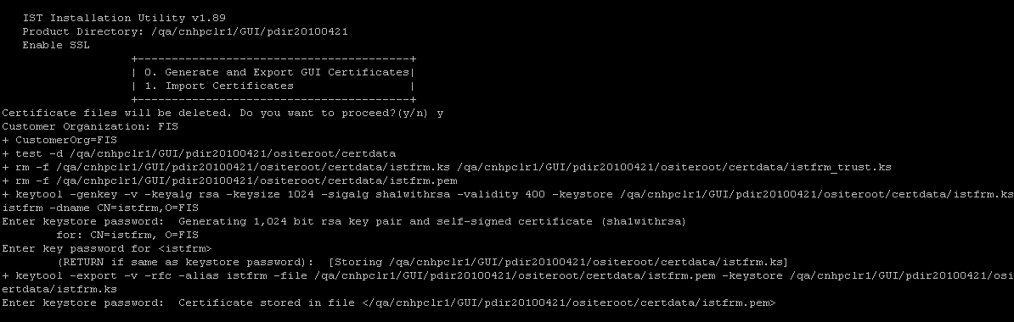
- Keystore(istfrm.ks) and permission(istfrm.pem) files are created in the path $OSITE_ROOT/certdata
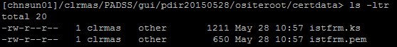
- Copy istfrm.pem file to the Server certdata path $OSITE_ROOT/certdata
Note: After copying istfrm.pem file to $OSITE_ROOT/certdata, Enable SSL -> Import Certificates has to be done. For further details refer Server Installation guide.

- Also, ensure that files istnodeagt.pem, oentsrv.pem, oassrv.pem files from Server side path $OSITE_ROOT/certdata are copied to the gui side path $OSITE_ROOT/certdata as shown below.
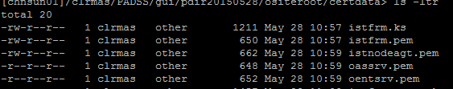

- 1. Import Certificates for GUI

- Ensure the files above were transferred and copied to $OSITE_ROOT/certdata
- Run pdeploy and select Enable SSL.
- Select Import Certificates and enter "y" to proceed.
- Enter the password used in Nodeagt_key_manager_pass in the System Variables for product install in "Install Server". The password is not displayed so if entered incorrectly the procedure will fail.
- For option Trust this certificate? Enter "y" and press Enter. The entered value is not displayed.
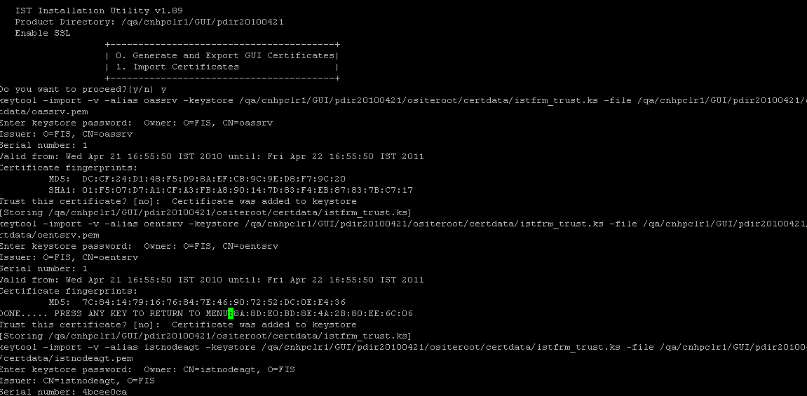

- Press Enter to return to the Enable SSL menu.
- Securely transfer and store the GUI application's key stores (istfrm.ks and istfrm_trust.ks) in the "Gui_webserver_encrypted_file_system/certdata" directory. The Gui_webserver_encrypted_file_system is the directory specified in the GUI Global Variables in section 6 Install GUI procedure. It is recommended that you store the files in an encrypted file system.

For example: istfrm.ks and istfrm_trust.ks files from the gui side path $OSITE_ROOT/certdata to encrypted directory webserver certdata path as shown below

[chnsun01]/clrmas/PADSS/clr/enc27may/webenc/certdata> ls -ltr
total 8
-rw-r--r-- 1 clrmas other 1457 May 28 11:01 istfrm_trust.ks
-rw-r--r-- 1 clrmas other 1211 May 28 11:01 istfrm.ks

25) Start the Administration Processes in Server side:
- Starting istnodeagt
    - Login as the clearing administrative user on the host (node) where the clearing is installed
    - Type "istnodeagt" at the command line.

- Starting oassrv and oentsrv
- Login as the administrative user on the host (node) where oassrv and oentsrv is configured to run.
- Type "oassrv -b" at the command line. The prompt below is displayed:
Enter PEM passphrase:
Press Enter without entering a passphrase.
- Type “oentsrv -b" at the command line. The prompt below is displayed:
Enter PEM passphrase:
Press Enter without entering a passphrase.

- 12. Generate WAR File

- This option sets up the parameters in various files required for GUI configuration and generates a WAR file in the location specified in step 3 Create GUI database
- Below two files are to be securely transferred:
- <Gui_webapp>.war The war file to be deployed to webserver.
- prot_props.tar The tar file containing property files to be protected in an encrypted file system.Deploy the WAR file created as per the web server specific notes.
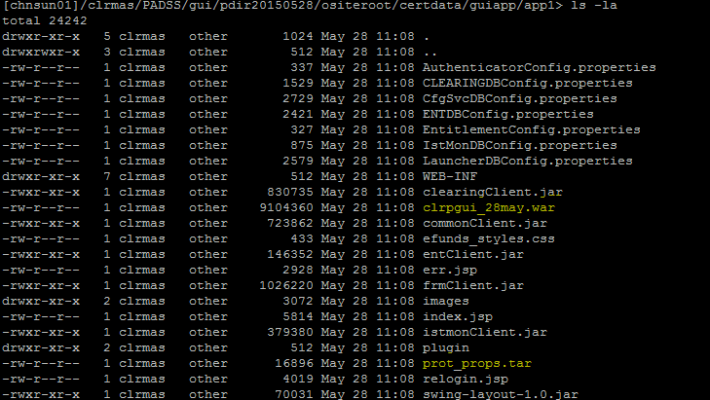

- To complete the process deploy the generated WAR file. Ie, Copy the war file to the path $TOMCAT_HOME/webapps

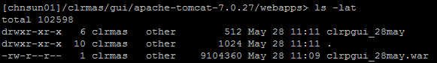

- Copy prot_props.tar to the encrypted folder protected directort path
Example: /clrmas/PADSS/clr/enc27may/webenc/prot_dir

- Extract the content of prot_props.tar file with the below command
tar –xvf <prot_props.tar>

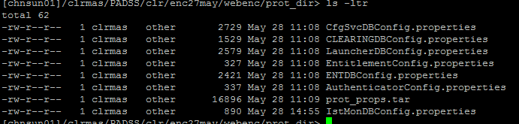

- Restart tomcat with the commands $TOMCAT_HOME/bin/shutdown.sh and $TOMCAT_HOME/bin/startup.sh
- Get the port for Gui URL from the location $TOMCAT_HOME/conf> grep port server.xml
Example:

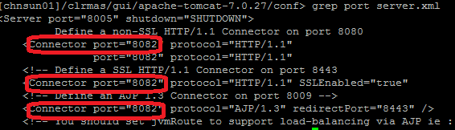
- GUI URL should be in the format “http://<UnixIPAddress>:ConnectorPort/<GuiWebappName>/inodex.jsp”

Example: http://10.74.153.17:8082/clrpgui_28may/index.jsp

- Enter “admin” as User name and password should be the one defined during Entitlement pdeply configuration in Server side
